## Problem 1: Write a program that prompts the user for a measurement in meters, and then converts it in to miles, feet, and inches.

Algorithm: 1) we also need the math libraray for this problem

2) prompt the user for a input allow fractions

3) capture the input in meters type = double

4) declare constants

METER_TO_MILE = 0.000621371;

METER_TO_FOOT = 3.28084;

METER_TO_INCH = 39.3701;

5) initilize calculation variables miles, feet, inches type = double

6) initilize output variables roundedMiles, roundedFeet, roundedInches type = double

7) set the output variables to the rounded value of calculation variables **there has to be a better way to d this**

8) output: meters + " meters is equal to ==>\t" + miles + " miles or rounded to ==>\t" + roundedMiles + " miles."

9) output: meters + " meters is equal to ==>\t" + feet + " feet or rounded to ==>\t" + roundedFeet + " feet."

10)output: meters + " meters is equal to ==>\t" + inches + " inches or rounded to ==>\t" + roundedInches + " inches."

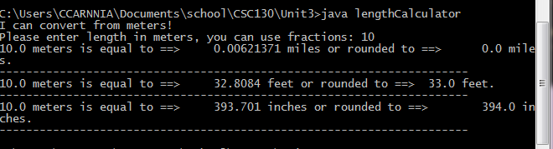

## Problem 2: Write a problem that prompts the user for a radius and then prints:

The area and the circumference of a circle with that radius

The volume and surface area of a sphere with that radius

Algorithm: 1) prompt the user for a radius allow fractions

2) capture input value in radious type = float

3) set a constant for PI typle = float value = 3.14159265359

4) output: "You entered:\t" + radius + "\t and Pi is:\t" + PI

5) area = Pi * radias ^ 2

output: "The AREA of that circle is ==>\t" + (float)(PI * (radius * radius)) + " square units"

6) circumference = Pi * radious * 2

output: "The CIRCUMFERENCE of that circle is ==>\t" + (float)(PI * (radius * 2)) + " units"

7) circumference of sphere = 4 * Pi * radious ^ 2

output: "The CIRCUMFERENCE of a sphere with that radius is ==>\t" + (float)(4 * PI * (radius * radius)) + " square units"

8) volume of a sphere = 4/3 * Pi * radious ^ 3

output: "The VOLUME of a sphere with that radius is ==>\t" + (float)( (4/3) * PI * (radius * radius * radius)) + " units cubed"

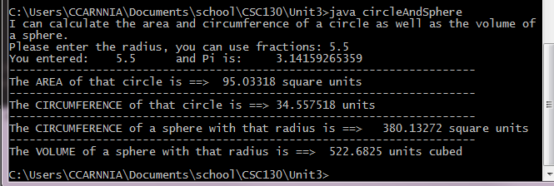

## Problem 3: Write a program that reads in an integer, and breaks it into a sequence of individual digits.

For example, the input 16384 is displayed as 1 6 3 8 4 You may assume that the input has no more than five digits and is not negative.

Algorithm: 1) prompt the user for a 5 digit whole number

2) capture the number in inputNumber type = int "we could do string too but this way we allow for error to be shown when the user types in none numeric data"

3) cast the integer as a string so we can loop throught it stringOfInputNumber type = String

4) get the lenght of stringOfInputNumber length type = int

5) initilize a counter i type = int

6) as long as counter i < lenght

output value of " + i + "th digit is ==> \t" + stringOfInputNumber.charAt(i) **this wouldn't work if we wanted to show the value of the Ones column first**

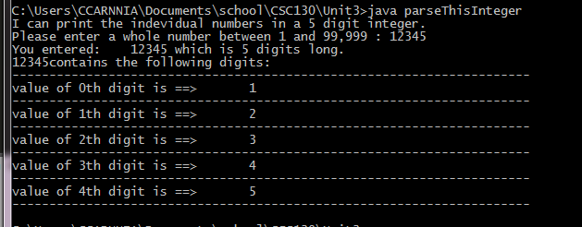

## Problem 4: Write a program that asks the user to input:

The number of gallons of gas in the tank

The fuel efficiency in miles per gallon

The price of gas per gallon

Then print the cost per 100 miles and how far the car can go with the gas in the car..

Algorithm: 1) prompt the user for gallons of gas in the car / allow fractions

2) capture the return value in inTheTank type = float

3) proment the user for mpg / allow whole number only

4) capture the returned value in mpg type = int

5) prompt the user for price of gas / allow fractions

6) capture the returned value in gasPrice type = float

7) output: "With gass at $" + gasPrice + " per gallon, going 100 miles will cost you $" + (gasPrice * 100)

8) output: "Since your car's efficiency is " + mpg + " mpg and given that you have " + inTheTank + " gallons in the tank, by my calculations you can go " + (int)(mpg * inTheTank) + " miles before you run out of gas."

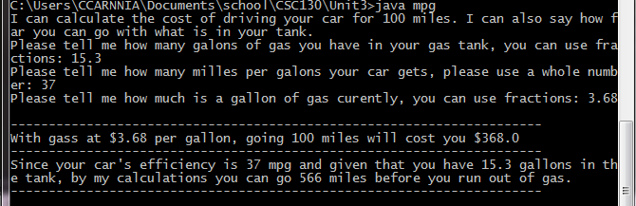

## Problem 5: Writing your name in large letters using strings.

Algorithm: Use try/error to output the closest thing to the shape of C A S E Y

when possible use \t instead of blank sparse

